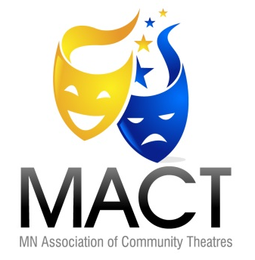
Minnesota Association of Community Theatres
245 Cedar Ave Minneapolis, MN 55454 www.MACT.net Treasurer@MACT.net
The Minnesota Association of Community Theatres is a nonprofit, educational organization. Our purpose is:
- to promote standards of excellence in theatrical endeavors in communities throughout Minnesota;
- to encourage, channel and facilitate the exchange of ideas among theatres to better foster their growth and improvement;
- to encourage the theatre arts in the state through such educational devices as workshops, festivals, contests, conferences and other means which the Board of Directors feels would be effective.

Membership Application
Individuals
Benefits:
Discount* on MACT festivals, conferences, workshops and other events
Periodic newsletters - Vote in MACT Board of Director elections
Free listings on the MACT website for your theatre related services
Additional benefits under development
Regular Individual Member | $25
Seniors (65+), Students, Fixed Income, First-Time Members | $15

Community Theatres
Benefits:
Discounts* on MACT festivals, conferences, workshops and other events
Discounts* on advertising in MACT newsletters and programs
Periodic newsletters - One representative on the MACT Board of Directors with full voting rights
Free listings on the MACT website for your theatre’s auditions, performances and other events
Free listings on the MACT website for items for sale or rent and help wanted ads
Additional benefits under development
Annual Budget under $25,000 | $50
Annual Budget of $25,000 to under $50,000 | $60
Annual Budget of $50,000 to under $100,000 | $80
Annual Budget of $100,000 to under $500,000 | $100
Annual Budget of $500,000 to under $1,000,000 | $200
Annual Budget of $1,000,000 and above | $300

Other Organizations
Benefits:
Discounts* on MACT festivals, conferences, workshops and other events
Discounts* on advertising in MACT newsletters and programs
Discount on sponsorships of MACT festivals, conferences, workshops and other events.
Periodic printed and electronic newsletters - Featured link on MACT’s website
Bronze Member (5% discount* – small link) | $50 - $99
Silver Member (10% discount* – med link) | $100 - $249
Gold Member (25% discount* – large link) | $250 (or more)

(* Limit of 2 discounted registrations and 2 discounted ads per event)
As an IRS 501(c)(3) organization, donations made to MACT are tax deductible as charitable contributions.
To join, complete the application on the back of this page
Individuals: Fill out the Contact 1 section.
Community Theatres: Fill out all three sections.
Other Organizations: Fill out the Theatre/Organization Info section.

Theatre/Organization Info
Theatre/Organization Name:
Address:
City State Zip:
Contact Name:
Website:
e-mail Address:
Phone: | Will you offer a ticket discount to MACT members? Y N If Yes, amount:
Theatre Type: Semi/Professional Community University/College Other:
Contact 1
Name:
Address:
City State Zip:
e-mail Address:
Phone:
Contact 2
Name:
Address:
City State Zip:
e-mail Address:
Phone:

Additional Donation (MACT is an IRS 501(c)(3) organization. Donations are tax deductible as charitable contributions.)
No Additional Donation
Supporting Player | $25 - $49
Stage Manager | $50 - $99
Director | $100 - $249
Producer | $250 - $499
Actor | $500 - $999
Star | $1,000 - $4,999
Philanthropist | $5,000 or more
Mail this application with your check to: MACT 245 Cedar Ave Mpls, MN 55454
or email this completed form to Treasurer@MACT.net and make payment on-line at: https://buy.ticketstothecity.com/venue.php?org_id=422

